**Healthcare Analytics - Capstone Project**

**View 1: Diabetic/Non-diabetic using Shapes**

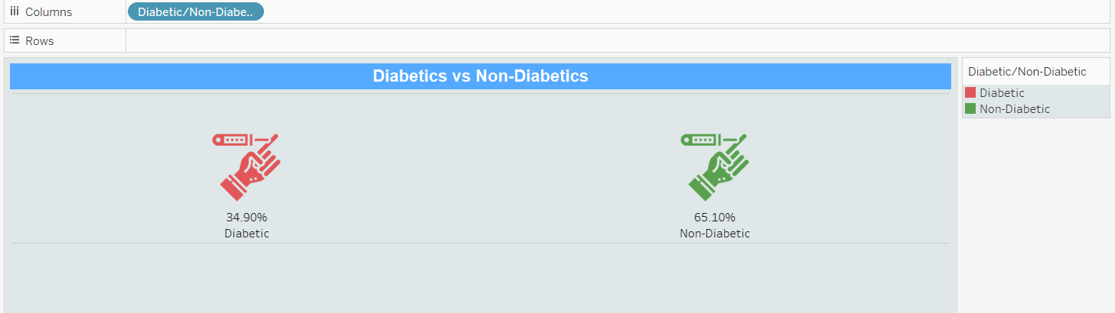

**View 2: Patient summary by Blood Pressure category**

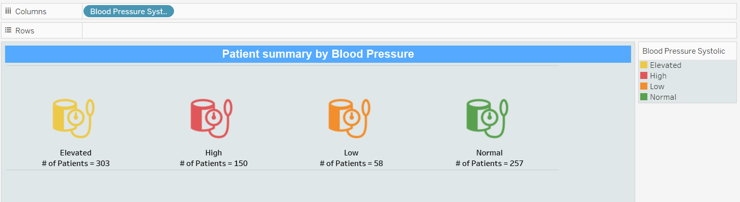

**View 3: Create a Histogram to show Body Mass Index (BMI) by Age Groups.**

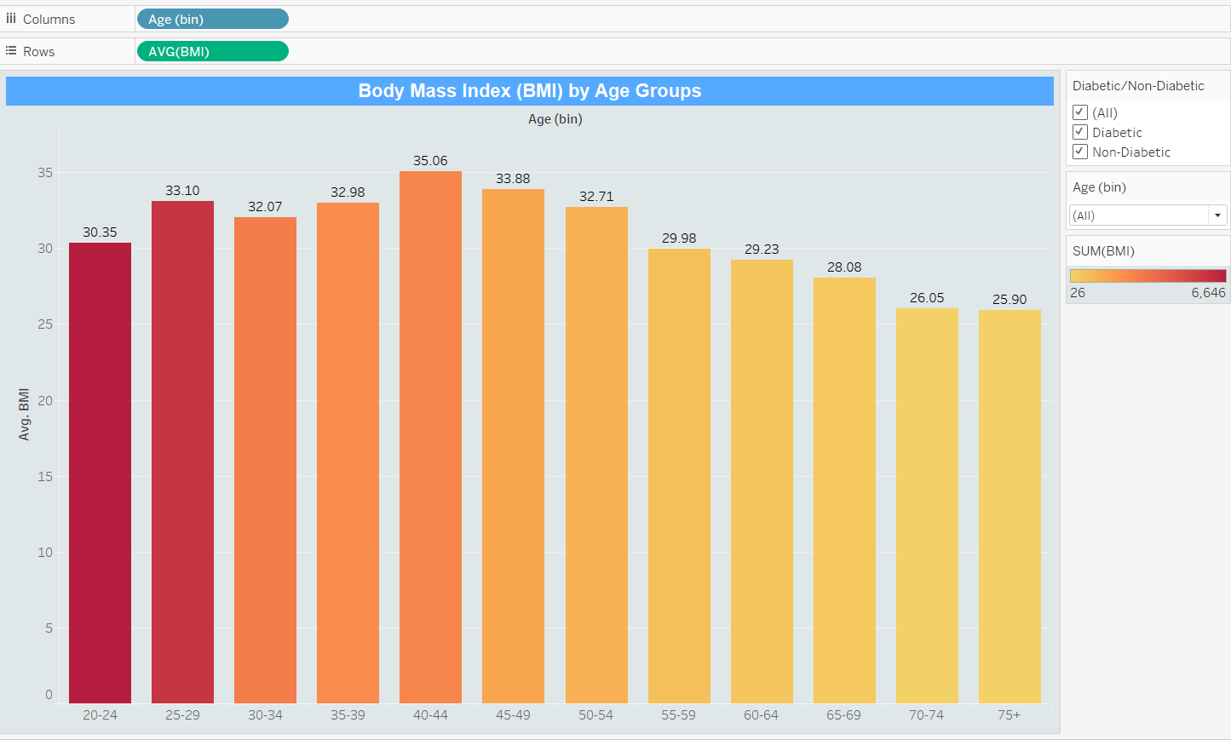

**View 4: Single Bar showing percent distribution of patients by BMI type**

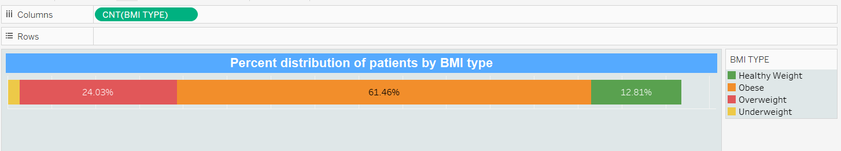

**View 5: Bar Chart showing Patient break down by Blood Pressure and Diabetes**

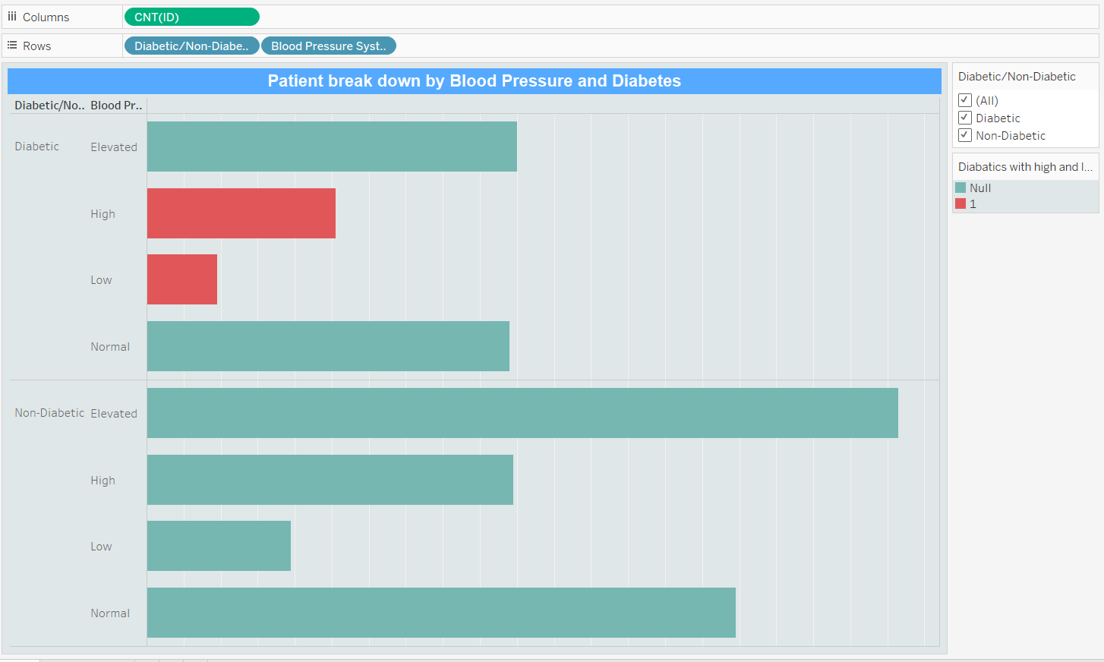

**View 6: Build a HEAT MAP showing several health factors by Age group**

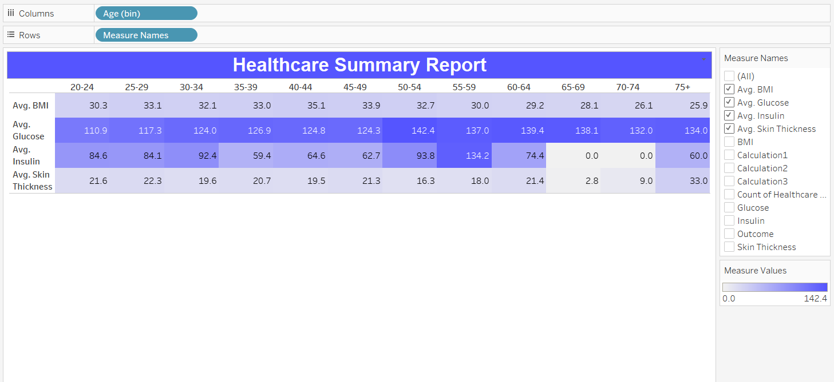

**Dashboard 1**



**Dashboard 2**

